**Project Proposal Instructions**

**Names**:

Adi Cohen – 207403049

Shir Shevach - 322407701

Odelia Harroch - 346143761

**1. Problem:**

The problem we aim to address is creating an AI agent that can play the game of [Go](https://he.wikipedia.org/wiki/%D7%92%D7%95_(%D7%9E%D7%A9%D7%97%D7%A7)) on a 9x9 board. While Go is known for its complex strategies and vast search space, we are interested in developing an efficient AI that can make intelligent moves without requiring extensive computational resources. A smaller board size (9x9) allows us to focus on fundamental strategies and heuristics while still providing a challenging environment for both human and AI players. We chose this problem to explore the balance between strategic depth and computational efficiency, leveraging limited resources effectively.

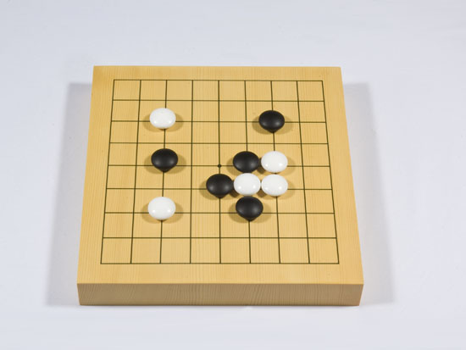

**2. Solution:**

**1. Monte Carlo Tree Search (MCTS) with Heuristics:**

MCTS is known for its efficiency in exploring large decision spaces by simulating random playouts and using the results to inform future decisions. This makes it well-suited for games like Go, where the branching factor is high. Additionally, Incorporating heuristics into MCTS allows us to guide the search process more effectively. For instance, prioritizing moves that connect stones or cut opponent stones can lead to better performance without significantly increasing computational complexity.

**2. Reinforcement Learning (RL) - MDP:**

RL allows the AI to improve by learning from its own experiences, making it adaptable and capable of discovering complex strategies over time. Modeling Go as a Markov Decision Process (MDP) helps in structuring the problem in a way that is amenable to RL techniques. This provides a clear framework for states, actions, and rewards.

**3. Previous work:**

We have not found references to a similar Go AI project in the provided school works. However, significant work has been done in the field of Go AI, with notable examples being AlphaGo and other research projects.

**4. Evaluation:**

**Win Rate**: Measure the AI's win rate against different opponents, including random players, heuristic-based players, and possibly human players. This metric will indicate the overall effectiveness of the algorithms in winning games.

**5. Extra:**

We are currently undecided on whether to implement Monte Carlo Tree Search (MCTS) or Markov Decision Processes (MDP), or a combination of these methods for our solution. We would greatly appreciate your insights and recommendations on which approach would be most suitable for our project.